**Deliverable 04**

**Members: Section: BSCS-K**

* **Muhammad Mujtaba i222123**
* **Fatima i221074**
* **Zirwah Khalil i220748**

**Domain Model**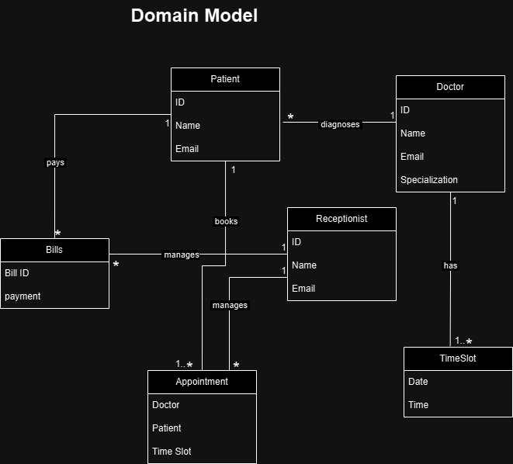

**22i-0748**

**BOOK APPOINTMENT:**

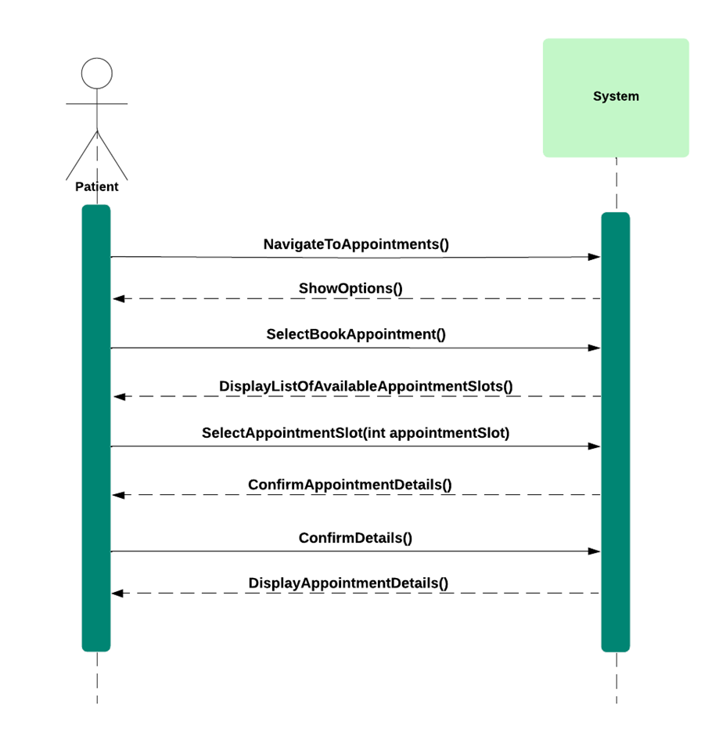

**UPDATE APPOINTMENT:**



**CANCEL APPOINTMENT**



**ACCESS PATIENT PORTAL:**



**PATIENT ENTERS INVALID CREDENTIALS**

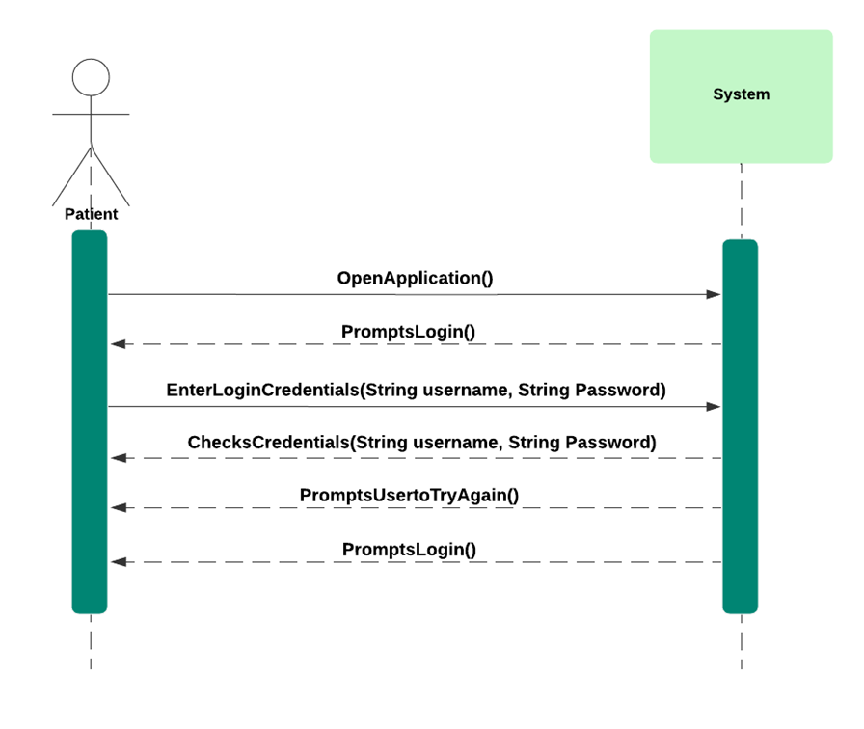

**PATIENT FORGETS PASSWORD**



**VIEW DOCTOR PROFILE**



**PAY BILL**

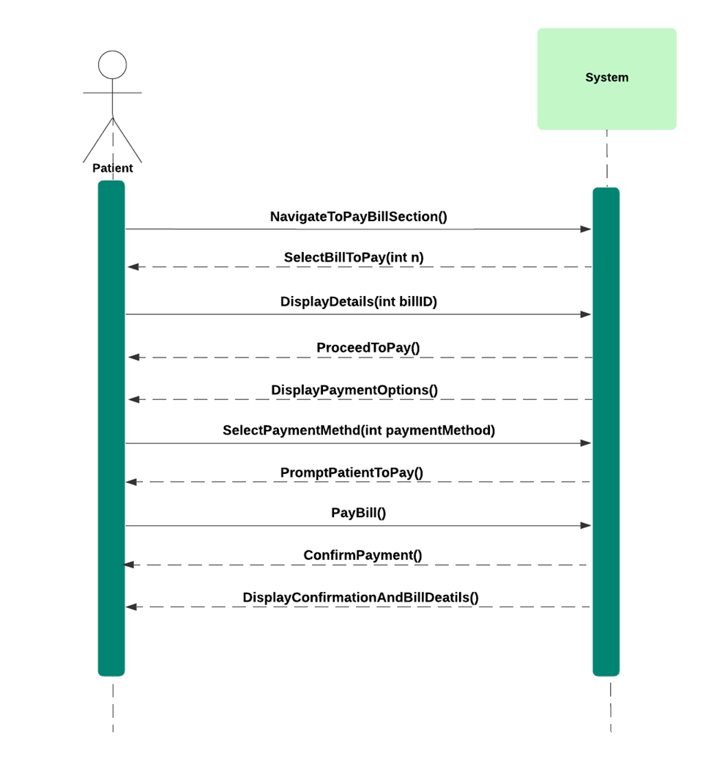

**PAYMENT DECLINED**



**ACCESS RECEPTIONIST PORTAL**



**22i-1074**

**Register Patient:**

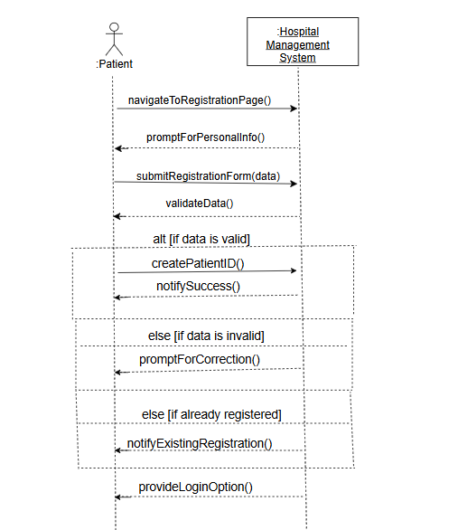

**Manage Patient Health Records:**

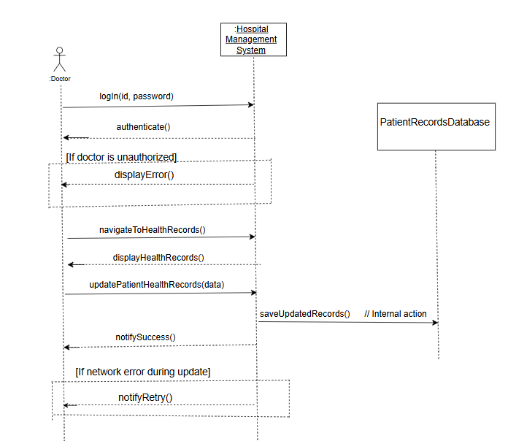

**Remove User (Patient/Doctor/Receptionist):**

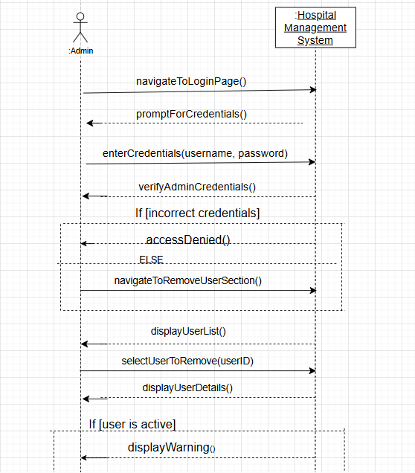

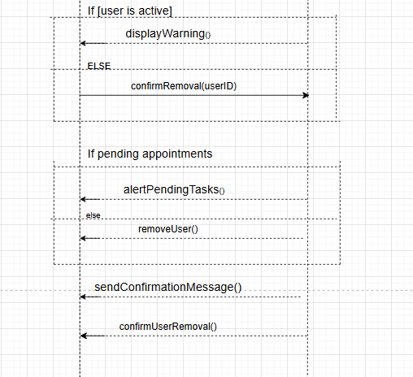

**Access Doctor Portal:**

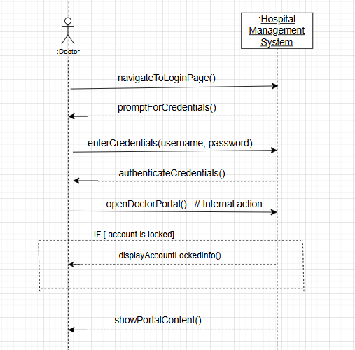

**SD**

**22i-0748**

**BOOK APPOINTMENT**

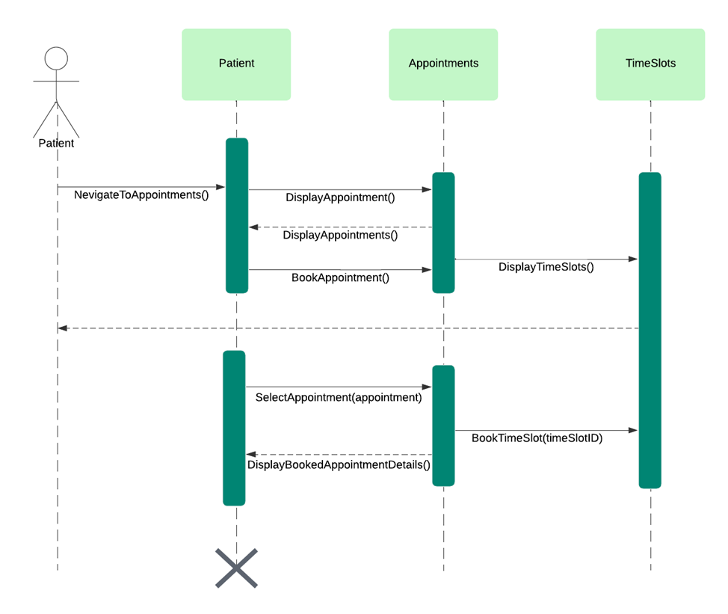

**VIEW DOCTOR PROFILE**

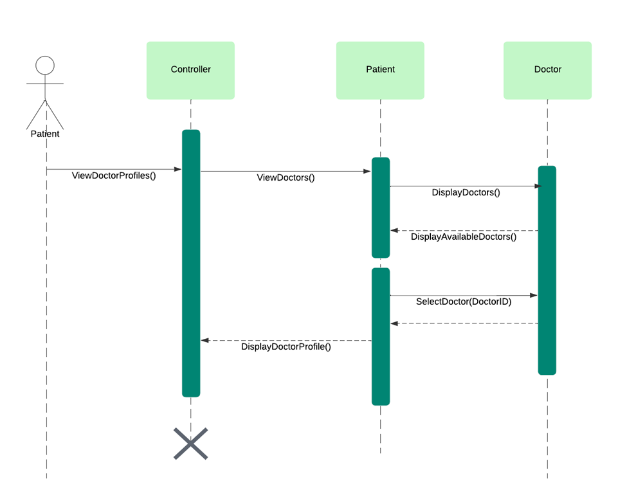

**PAY BILL**



**ACCESS RECEPTIONIST PORTAL**

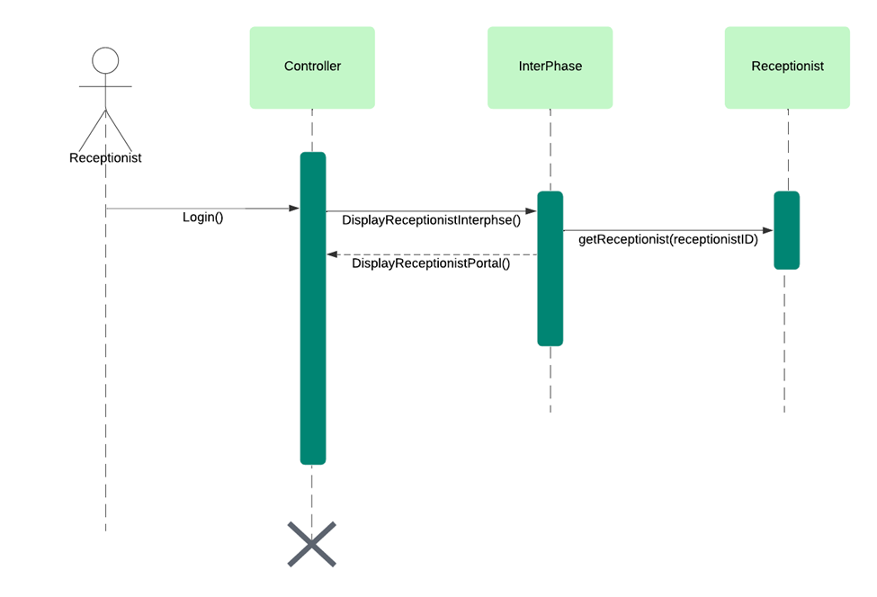

**ACCESS PATIENT PORTAL**



**22i-1074 SD**

**Register Patient:**

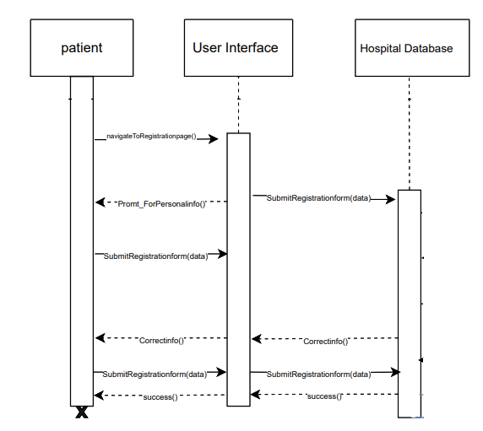

**Remove User (Patient/Doctor/Receptionist):**

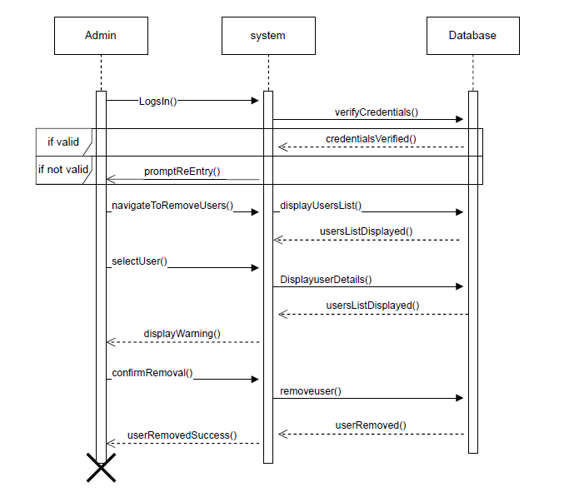

**Manage Patient Health Records:**

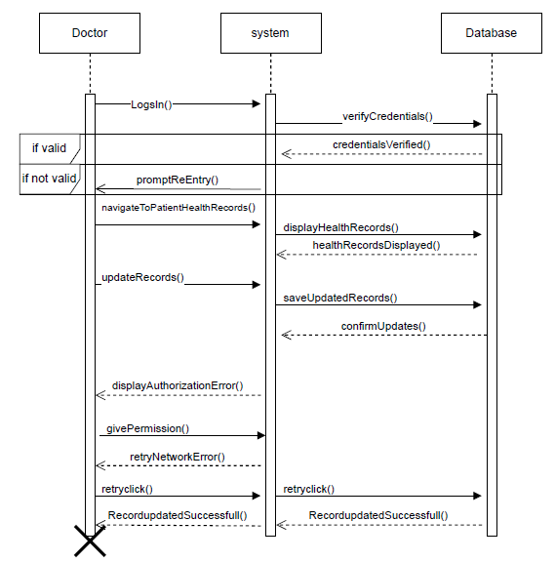

**Access Doctor Portal:**

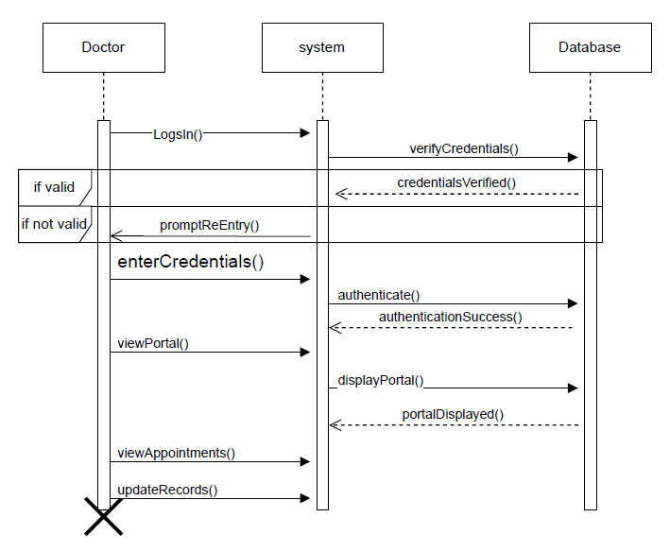

**22i-2123 SSD and SD**

**Manage Billing**

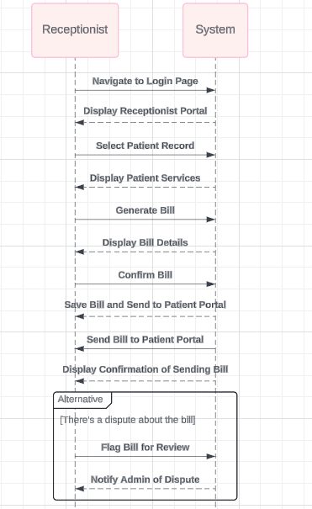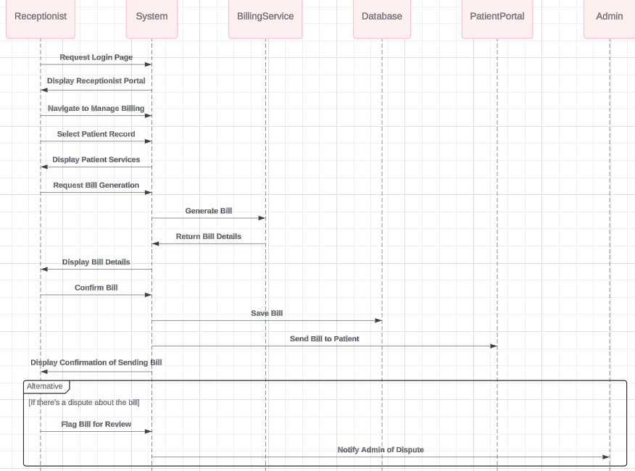

### **View Patient’s Medical History Report**

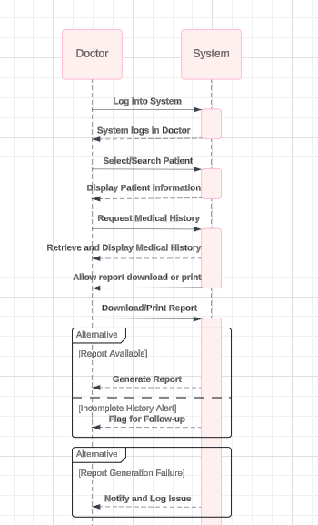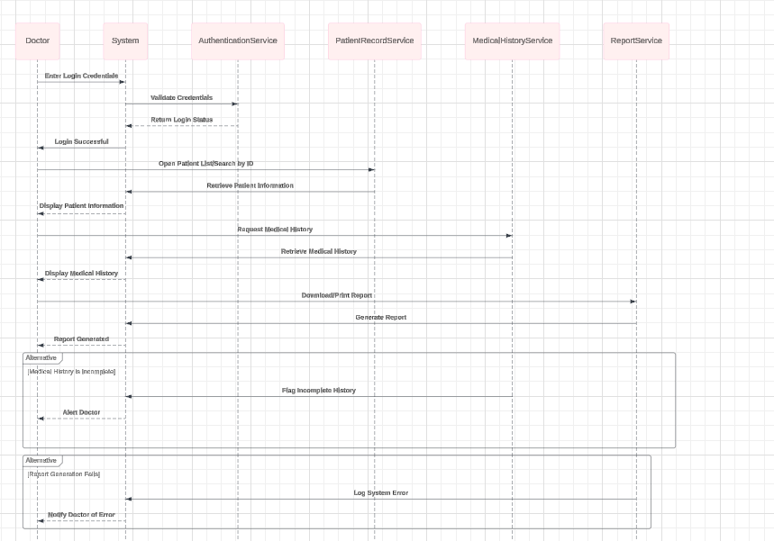

**Register Doctor/Patient / Receptionist**

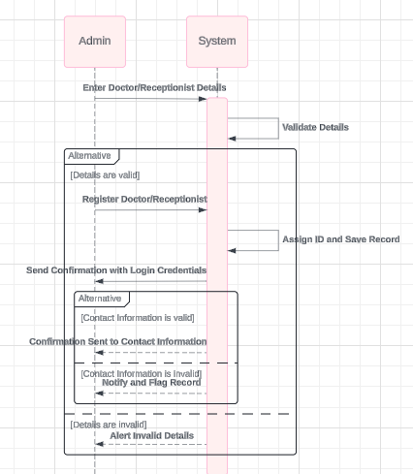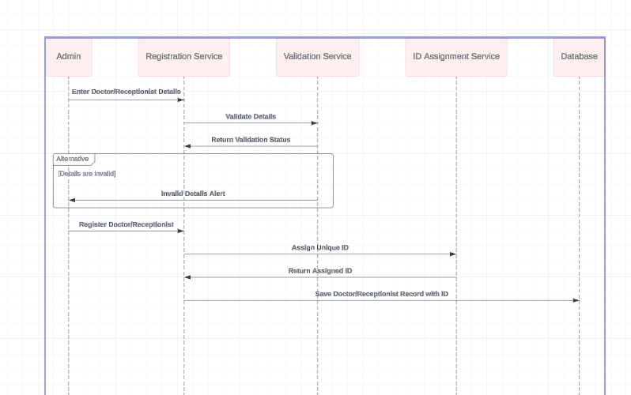

**Schedule Appointment   
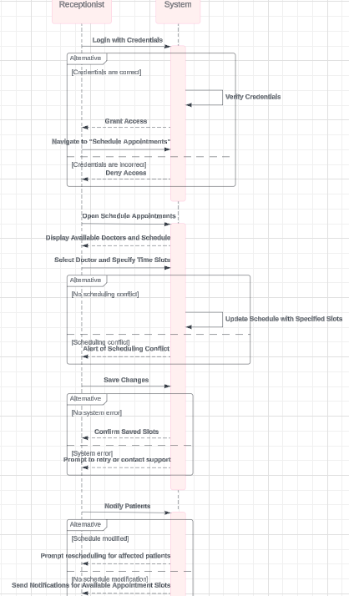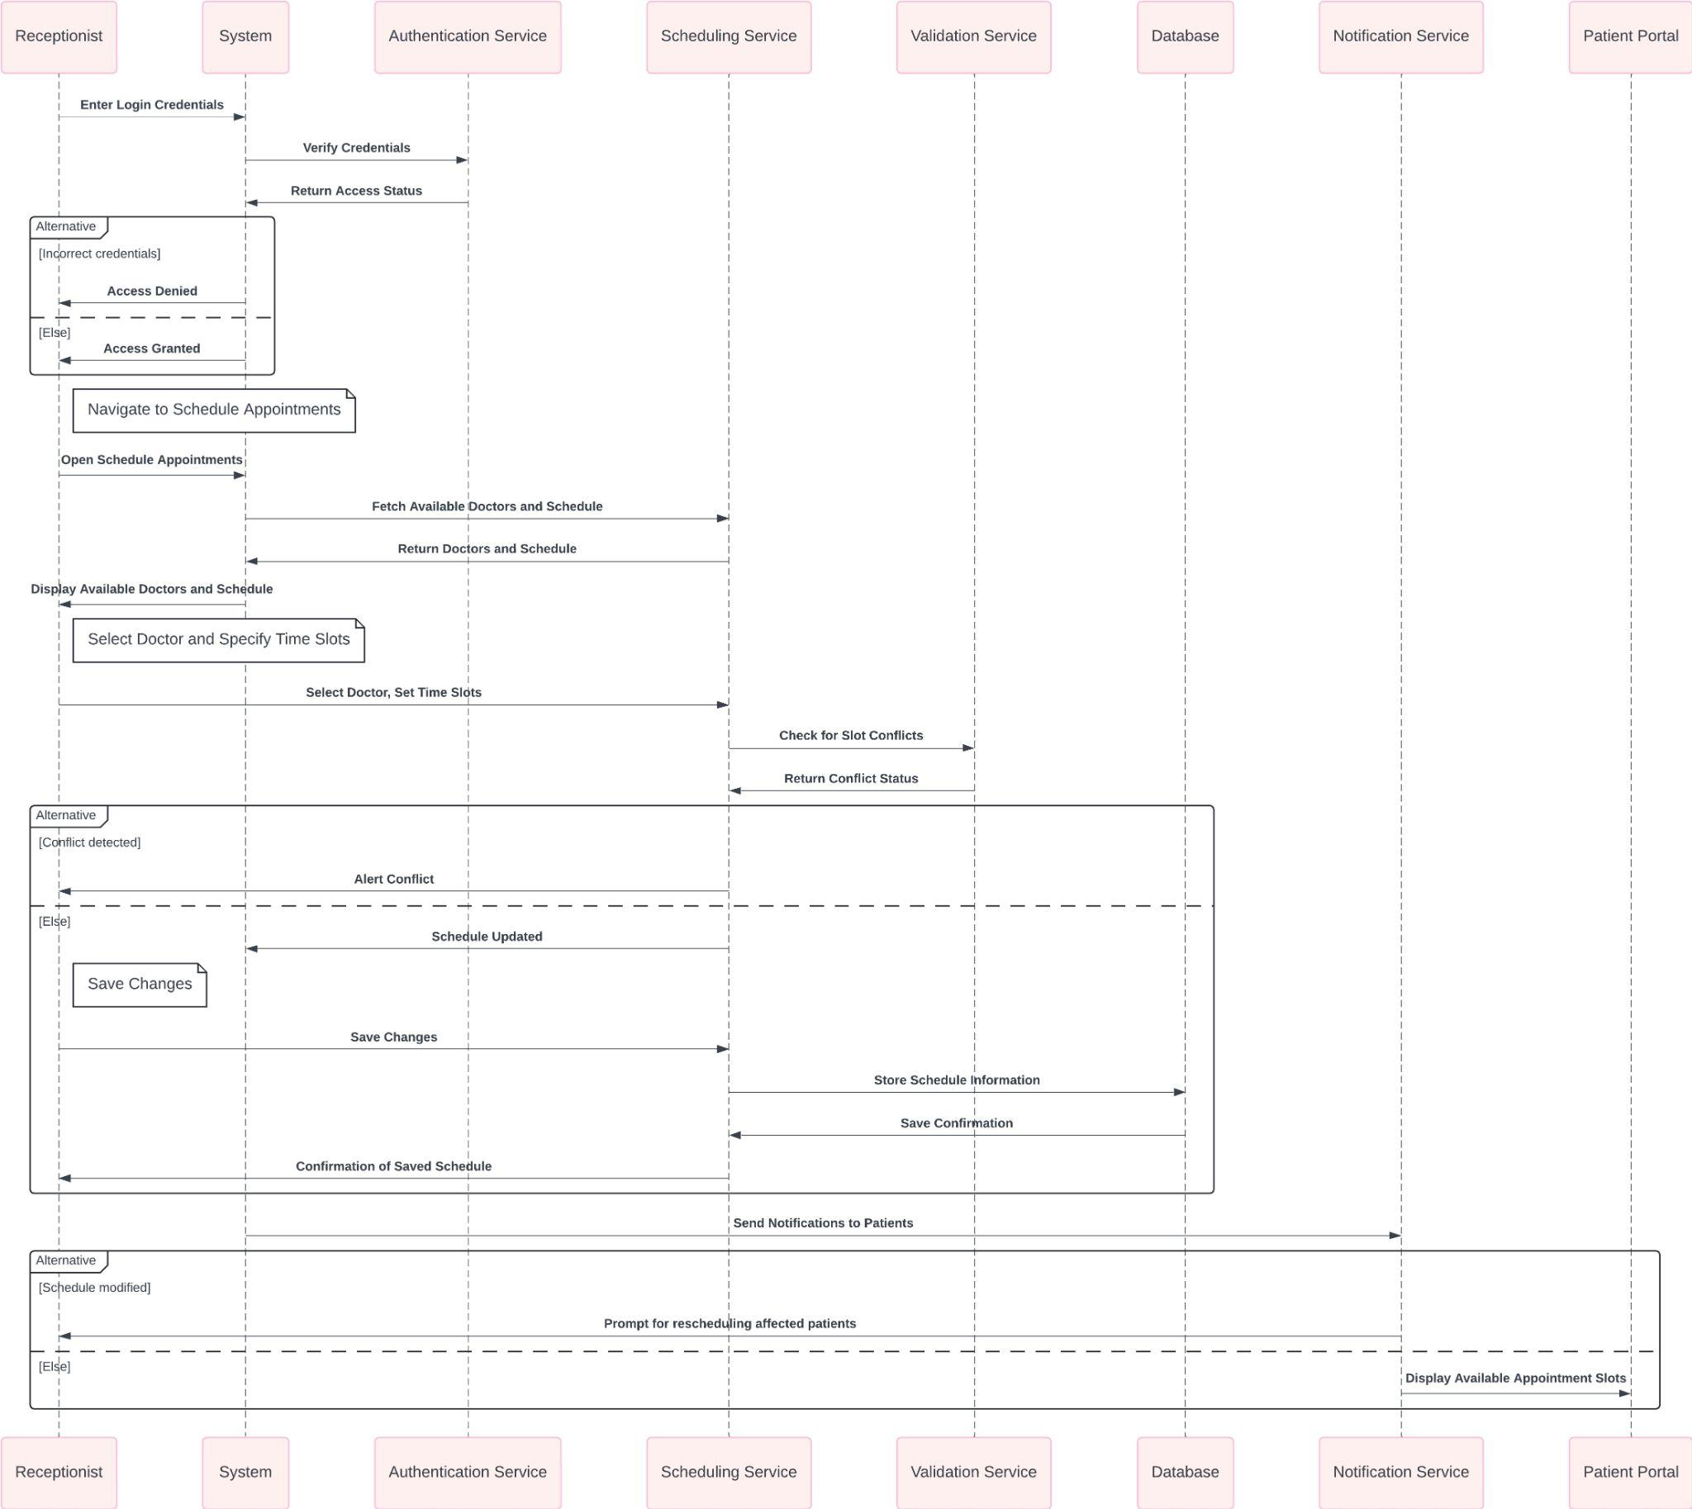**

**Accessing Admin Portal**

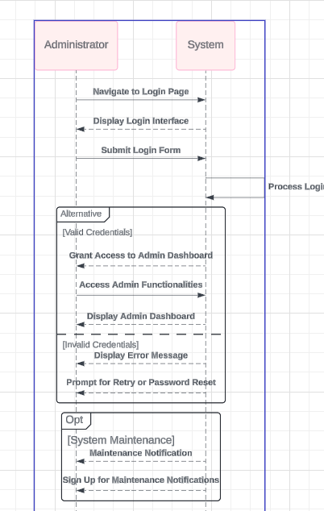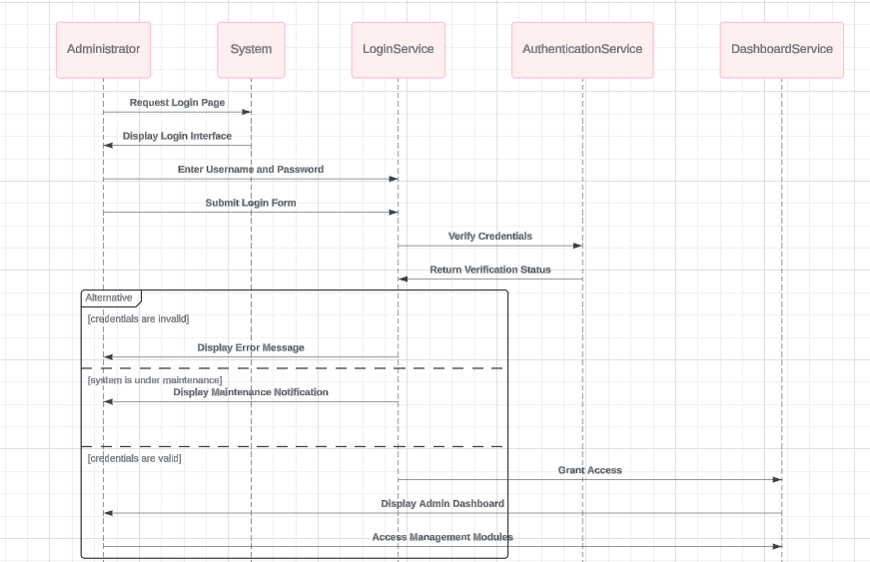

**Rate a Doctor and Provide Feedback**

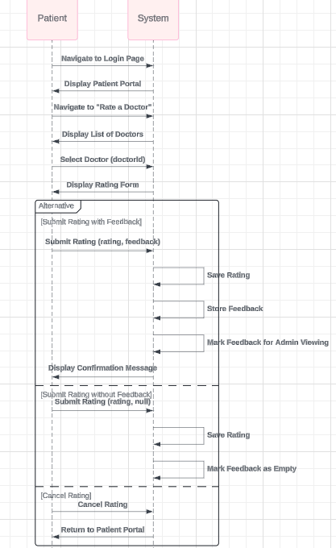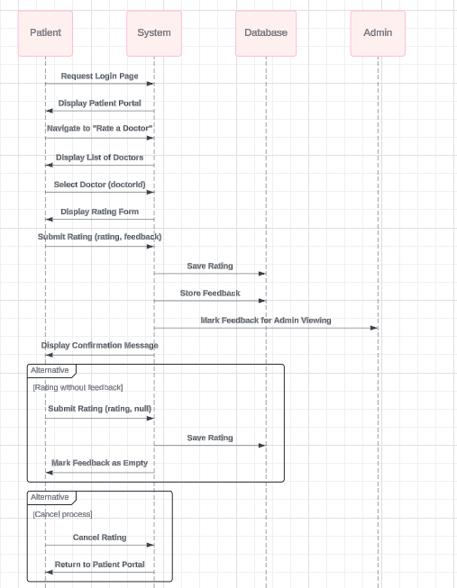

**Class Diagram**

